**Project Design Phase-II**

**Data Flow Diagram & User Stories**

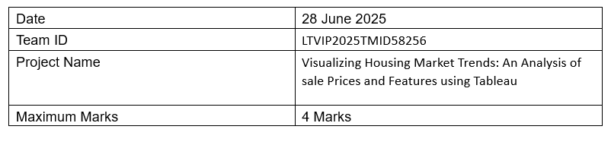

**Data Flow Diagrams:**

A Data Flow Diagram (DFD) is a traditional visual representation of the information flows within a system. A neat and clear DFD can depict the right amount of the system requirement graphically. It shows how data enters and leaves the system, what changes the information, and where data is stored.

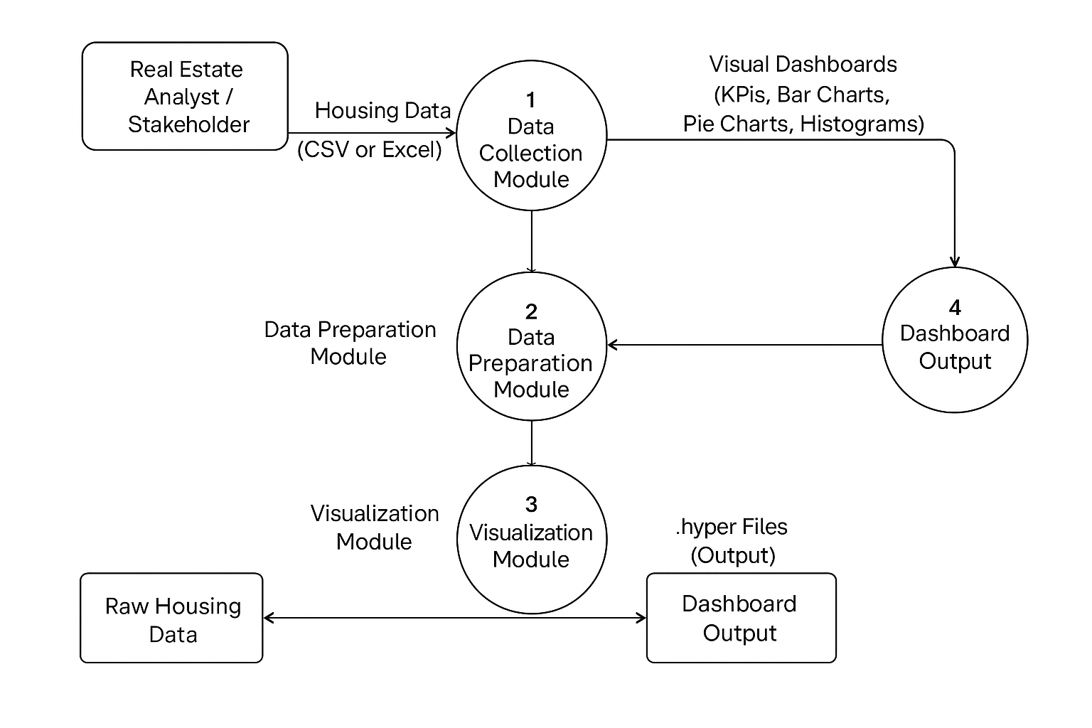

## User Stories

Use the below table to define user stories for this project:

|  |  |  |  |  |  |  |
| --- | --- | --- | --- | --- | --- | --- |
| User Type | Functional Requirement (Epic) | User Story Number | User Story / Task | Acceptance Criteria | Priority | Release |
| Analyst | Data Collection | USN-1 | As an analyst, I want to upload the raw housing dataset to begin the data preparation process. | Dataset is uploaded successfully | High | Sprint-1 |
| Analyst | Data Cleaning & Transformation | USN-2 | As an analyst, I want to clean and filter the dataset using Tableau Prep for analysis. | Cleaned dataset is ready for export | High | Sprint-1 |
| Stakeholder | Visualization – KPIs | USN-3 | As a stakeholder, I want to see overall KPIs like average price and record count in the dashboard. | KPIs display correct values | High | Sprint-2 |
| Stakeholder | Visualization – Renovation | USN-4 | As a stakeholder, I want to compare renovation impact on sale prices using visualizations. | Histogram correctly shows renovation years vs sale prices | Medium | Sprint-2 |
| Stakeholder | Visualization – Age Features | USN-5 | As a stakeholder, I want to analyze house age against bathrooms, bedrooms, and floors. | Grouped bar chart displays counts accurately | High | Sprint-3 |
| Manager | Dashboard Sharing | USN-6 | As a manager, I want to download or share the dashboard insights with my team. | Dashboard is shareable via Tableau link or export | Medium | Sprint-4 |